 | Independent T-Test | Paired T-Test | Correlation | Regression | Multiple Regression | One-Way Between Subjects ANOVA | One-Way Repeated Measures ANOVA | Factorial ANOVA
Purpose | Compare means of 2 independent groups | Compare means of 2 related conditions | Measure strength & direction of relationship | Predict DV from 1 IV | Predict DV from multiple IVs | Compare means of 3+ independent groups | Compare means of 3+ related conditions | Compare means across multiple IVs and test interactions
Variables | 1 categorical IV (2 levels), 1 numerical DV | 1 categorical IV (2 related levels), 1 numerical DV | 2 numerical variables | 1 numerical IV, 1 numerical DV | Multiple numerical IVs, 1 numerical DV | 1 categorical IV (3+ levels), 1 numerical DV | 1 categorical IV (3+ related levels), 1 numerical DV | 2+ categorical IVs, 1 numerical DV
Assumptions | Independence, Normality, Homogeneity of Variance | Independent pairs, Normality | Linearity, Normality, Independence | Linearity, Independence, Homoscedasticity, Normality of residuals | Linearity, Independence, Homoscedasticity, Normality of residuals, No multicollinearity | Independence, Normality of residuals, Homoscedasticity | Independence, Normality of residuals, Homoscedasticity, Sphericity | Independence, Normality of residuals, Homoscedasticity
STATA Command | ttest DV, by(IV) | ttest var1 == var2 | pwcorr IV DV, sig obs | regress DV IV, beta | regress DV IV1 IV2 IV3, beta | anova DV IVestat esize | anova DV IV ID, repeated(IV)estat esize | anova DV IV1##IV2estat esize
Effect Size | Cohen's d | Cohen's d | Pearson's r | R² | R² | η² | η² | η², Partial η²
df | n − 1 | n − 1 | n − 2 | Model = k  Residual = n − k – 1  Total = n − 1 | Model = k  Residual = n − k – 1  Total = n − 1 | k − 1 | n − k | Depends on factor
Corrections / Follow-ups | — | — | — | — | — | Bonferroni (planned)Tukey (post-hoc)Welch/Brown-Forsythe | Greenhouse-Geisser (ε < .75)Huynh-Feldt (ε > .75) | Bonferroni (planned)Tukey (post-hoc)
Non-parametric | Mann-Whitney U  ranksum DV, by(IV) | Wilcoxon Signed Rank  signrank var1 = var2 | Spearman's rho  spearman var1 var2 | — | — | Kruskal-Wallis  kwallis DV, by(IV)dunntest DV, by(IV) ma(bonferroni) | Friedman Test | —

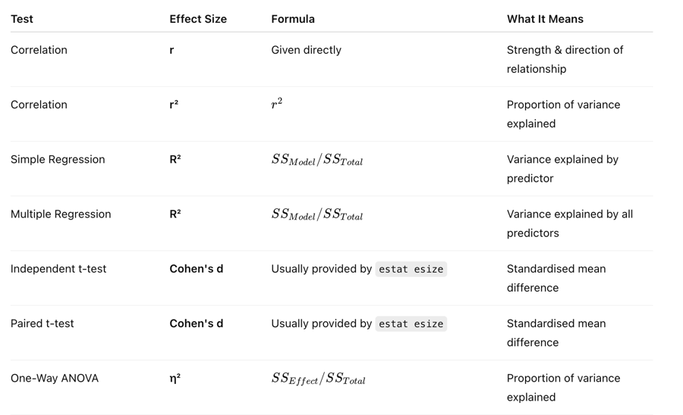
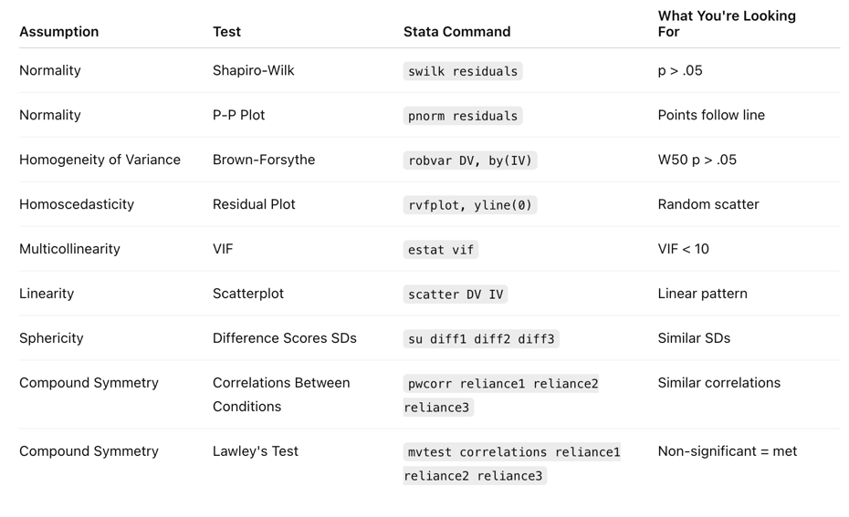
Effect Sizes
Assumption Tests

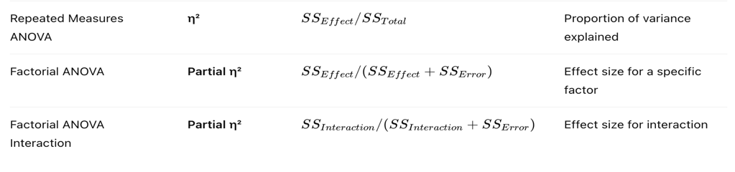
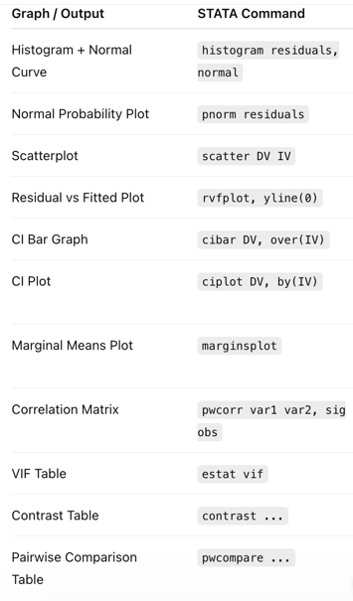
Graphs

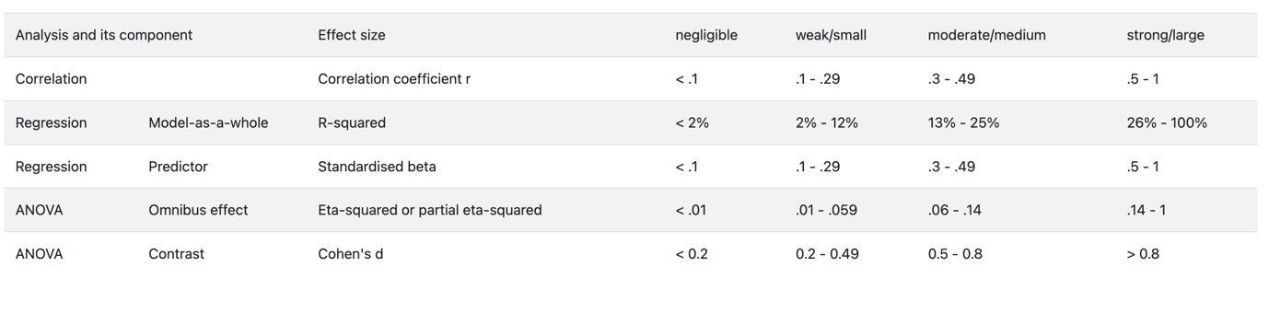

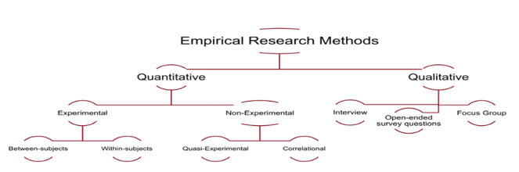
Degrees of Freedom

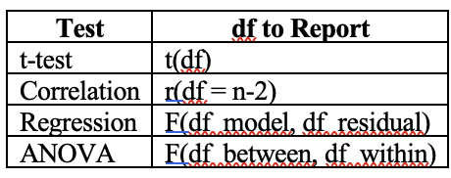

Test / Output | Common Wording / Clues | What You Can Conclude | Common Trap
Correlation | "Relationship", "Association", "Related to", "Linked to" | Variables are associated | Correlation ≠ causation
Regression | "Predicts", "Unique contribution", "Controlling for", "Best predictor" | Predictor uniquely predicts DV | Significant model ≠ all predictors significant
Significant β | "After controlling for..." | Unique predictor | Not causation
Independent t-test | "Difference between two groups" | Groups differ | Means differ ≠ significant
Paired t-test | "Before vs after", "Pre-post", "Same participants" | Scores changed | Mean change ≠ significant
One-Way ANOVA | "Three or more groups", "At least one group differs" | At least one group differs | Doesn't tell which groups
Post Hoc | "Which groups differ?" | Identifies specific groups | ANOVA alone can't do this
Factorial Main Effect | "Overall", "Across all participants", "Regardless of..." | Overall effect of IV | Doesn't address interaction
Interaction | "Depends on", "Different for", "Varies according to", "Moderates" | Effect of one IV depends on another | Doesn't tell where
Simple Effect | "Among women", "Within CBT", "At Time 1", "For males only" | Effect at a specific level | Not a main effect
Repeated Measures | "Across time", "Across conditions", "Same participants" | Scores differ over time/conditions | Doesn't tell which times differ
Contrast | "Specifically compare", "Planned comparison", "Hypothesis test" | Specific hypothesis supported | Doesn't mean all groups differ
Margins Table | "Cell means", "Predicted means", "Margins" | Descriptive pattern only | Not significance
Graph | Lines, bars, plotted means | Direction/pattern | Not significance
TIME@STRATEGY | A@B format | Time effect within each strategy | Not strategy effect
STRATEGY@TIME | A@B format | Strategy effect within each time | Not time effect
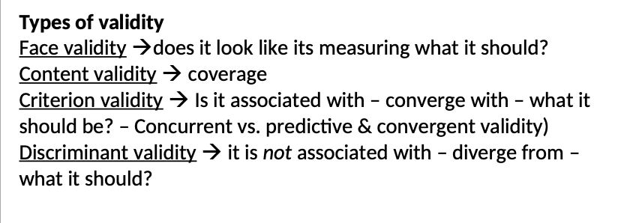
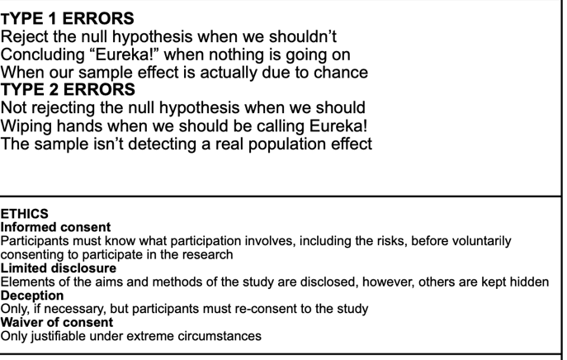
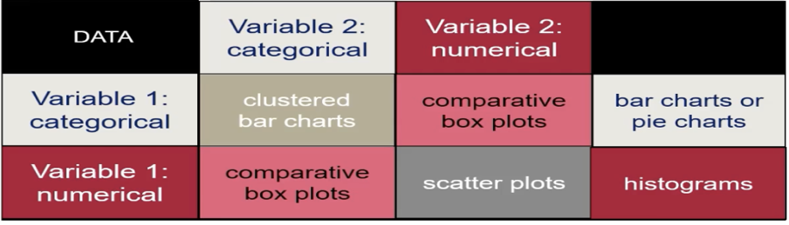
Recognising Outputs
Interpreting Outputs
If You See... | It's Probably...
r and p | Correlation
β coefficients | Regression
F and p with one IV | ANOVA
Multiple Fs for IV1, IV2, IV1×IV2 | Factorial ANOVA
Interaction term (gender#therapy) | Factorial ANOVA
A@B | Simple Effects
Margins / Predictive Margins | Descriptive Means
Contrast Table | Inferential Follow-Up
W50 (robvar) | Homogeneity of Variance
VIF | Multicollinearity
P-P Plot / pnorm | Normality
rvfplot | Homoscedasticity
diff1 diff2 diff3 | Sphericity Check
Lawley's Test | Compound Symmetry
Same participants measured repeatedly | Repeated Measures

